Problem statement

Our project introduces an innovative wheel designed to enhance performance across both smooth and rough terrains. Traditional wheels often struggle with stability and traction on uneven surfaces, leading to discomfort and reduced efficiency.

Solution

Our wheel addresses these challenges by integrating adaptive spring mechanisms that allow the wheel to dynamically adjust to surface irregularities. TerraFlex provides a smoother experience while maintaining efficiency on paved roads.

Objectives

* Create a wheel that is equally efficient on smooth roads and rough terrain.
* Ensure stability by using spring suspensions inside the wheel, as opposed to spokes.
* Avoid punctures as the wheel is *airless*

Final Idea

At our 7 day residency at Maker’s Asylum in Goa, we learnt various skills like woodworking, laser cutting and 3D printing. These skills were essential to make the wheel, since our project is purely *mechanical* with no coding involved.

Our final project is a 150mm diameter wheel with alternating spring and solid sections. The spring sections will absorb any terrain irregularities like rocks and broken ground, and the solid sections will maintain the same regular rotation on smooth roads.

**Chronological Progress**

***Pre-residency (online)***

We brainstormed different techniques and mechanisms which can help the wheel maintain stability without having to rely on external vehicle suspension. We took inspiration from the PATS wheel and NASA’s airless wheels for Mars missions. After researching different types of past innovative wheel designs, we decided on creating a wheel with alternating spring sections and solid sections. We designed the CAD models of the wheel on Fusion 360 during online team meetings.

***Residential***

We designed the testing track to test our wheel prototype on. We finalized on a 850mm length track with a slider and block attached above the wheel to act as the weight of the car. After comparing the ratio of the size of our prototype to the size of an actual wheel, we determined the weight acting on the wheel to be 70N. We then laser-cut the first-version of our bracket for the test track, and cardboard side plates for our side-track and tested the wood block as a slider. After multiple trials, we determined the slider dimensions to be 20mm x 70mm x 18mm. We then got our CAD models 3D printed with ABS, TPU and PLA. We assembled the wheel using super glue to stick the 3D printed parts together. We printed 5 different inner pieces and tested each one of them. We finally decided on using a Large Curve piece. Our final design used 8 solid sections and 8 spring sections with a total of 16 20mm springs.

Materials Used

* 4 x Cylinder - 3D Printed ABS - diameter 30mm and thickness 35mm. With a hole in the middle.
* 24 x Springs - length of 20mm and outer diameter of 10mm. Wire thickness 0.5mm
* 3D printing material - PLA 168g and 109g TPU and 304g ABS
* 850mm x 300mm Plywood with thickness 3mm with a 750mm x 17 mm slit *for side plate*
* 850mm x 300mm clear acrylic with thickness 1.7mm with a 750mm x 17 mm slit *for side plate*
* 20mm x 70mm x 160mm Plywood block *as slider*
* 150mm x 850mm - Sunboard x 2 for *base of track*

Project Mind Map

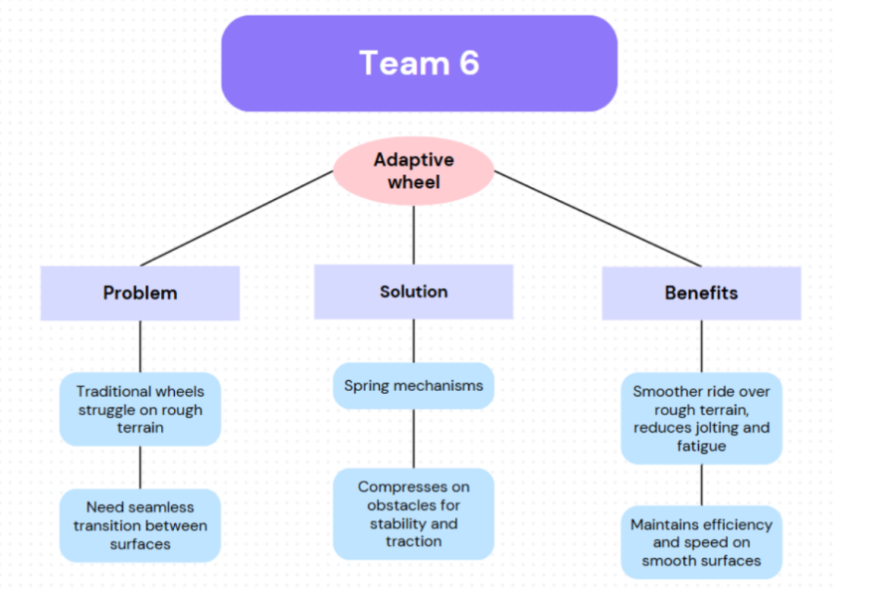

Block Diagram based on objectives

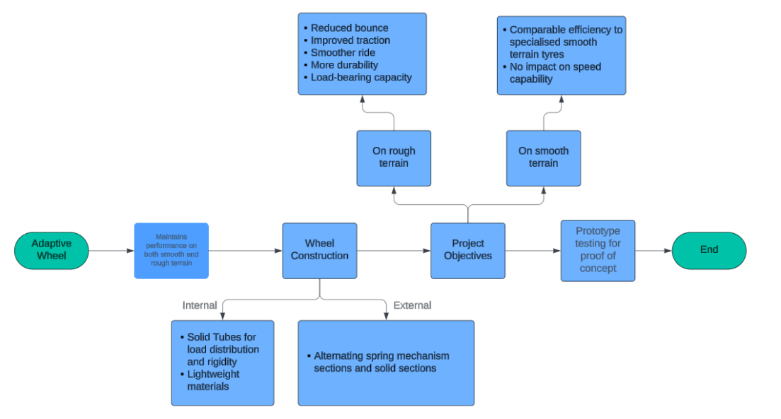

Final Wheel Model

